Pupil Premium Strategy Statement 2022 to 2023

School overview
Metric | Data
School name | Newbold Verdon Primary School
Pupils in school | 210 (not including Unit children)
Proportion of disadvantaged pupils | 23.8%
Pupil premium allocation this academic year | £66,785
Academic year or years covered by statement | 2022-23
Publish date | September 2022
Review date | September 2023
Statement authorised by | Lucy Collins
Pupil premium lead | Lucy Collins
Governor lead | To be agreed in Full Governors meeting

Disadvantaged pupil progress scores for last academic year - 2021 2022
Measure | Score
Reading | 15.4 steps (average should be 6 steps a year)
Writing | 15 steps(average should be 6 steps a year)
Maths | 12.3 steps(average should be 6 steps a year)

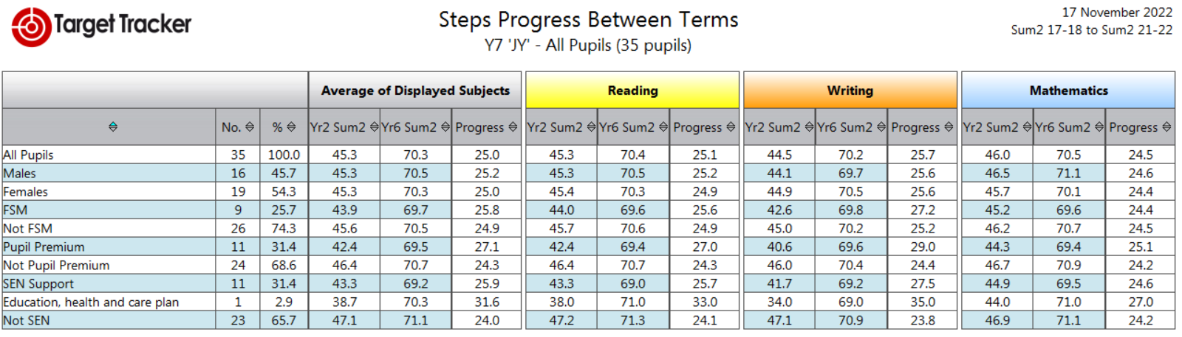

This table shows a comparison of in-school assessment for the whole class compared to the various groups. Pupil Premium pupils made slightly better progress to the class as a whole during 2021-2022.
Reading Progress  Whole class | Reading Progress PP | Writing Progress Whole Class | Writing Progress PP | Maths Progress Whole Class | Maths Progress PP | RWM Progress Whole Class | RWM Progress PP
25.1 | 27 | 25.7 | 29 | 24.5 | 25.1 | 25 | 27.1

Of the 11 Pupil Premium children:
- 5 are SEND
- 0 are LAC
- 4 joined the school after KS1
- 2 have other barriers to learning

Disadvantaged pupil performance overview for last academic year
Measure | Disadvantaged Yr 6  10 children | Whole Yr 6  34 Year 6
Meeting expected standard at KS2 | R 50%  W 50%  M 60%  RWM 30% | R 67%  W 65%  M 76%  RWM 44%
Achieving high standard at KS2 | R 10%  W 0%  M 10%  RWM 0% | R 21%,  W 0%  M 15%  RWM 0%
Previous Strategy Aims for Disadvantaged Pupils 2021 2022
Measure | Activity
Priority 1 | Buy and embed the use of high-quality books (matching our phonics scheme) across all year groups to increase reading for pleasure. Ensure less able children have age appropriate reading material.
Priority 2 | Establish regular reading opportunities for children in Y1-4 to ensure disadvantaged pupils lessen the learning Gap and achieve age-related expectations by KS2.
Priority 3 | Whole school development plan target for improving writing. CPD and resources acquired & embedded.
Priority 4 | Online learning resources for in school and home use.
Some in school barriers that the strategies addressed:
- Poor starting points in EYFS (90% of children entered Foundation below age expectation in 2019)
- Low level support from home – low level of home reading & support in learning
- Domestic/social issues causing disengagement with learning
- Lack of inspiration for some children - low aspirations and few cultural experiences
External barriers for some pupils:
- Low parental engagement with school
- Poor level of parental education for some
- Some attendance issues – specific family issues
- Social and emotional issues within some families

Outcomes to aspire to:
- Academic support to reduce the gap in attainment and progress across the school between PP and non-PP.
- Increased parental engagement & guidance in how to support at home. Learning valued and encouraged by pupils and parents
- Inspirational experiences to excite children into learning
- Decrease in stress/anxiety in children’s lives to enable better engagement in learning. Support for social and emotional needs provided in school.
- Improved attendance
- Greater engagement with online learning.
- Ensuring staff use evidence-based whole-class teaching interventions

Actual spending 2021 2022 | £65 297 received total  £16,384 on site resourcing  £48,913 staffing and intervention costs

Teaching priorities for current academic year 2022 2023
Aim: cumulative progress year on year of 6 steps + | Yr 1 | Yr 2 | Yr 3 | Yr 4 | Yr 5 | Yr 6 | Target date
Reading |  |  |  |  |  |  | Sept 23
Writing |  |  |  |  |  |  | Sept 23
Maths |  |  |  |  |  |  | Sept 23
Phonics – 80% of PP achieve expected standard |  |  |  |  |  |  | Sept 23

Targeted academic support for current academic year 2022 2023
Measure | Activity
Priority 1  To implement high quality, targeted teaching to narrow the gap in learning outcomes | - Tuition for disadvantaged children weekly for 10 weeks – years 2-6  - Tuition in phonics to narrow gaps in reading  - Homework club after school  - Fresh Start intervention in KS2  - Coaching of teaching to support effective planning
Priority 2  To ensure teaching is designed help pupils to remember long term the content they have been taught and how to integrate new knowledge into larger ideas | - Cognitive Science training for teachers and LSA’s  - Use of Cognitive Science strategies to improve memory and retention of knowledge
Priority 3  To assess and address language deficit to enable children to access a full and rich Literacy curriculum | - Wellcomm assessments carried out across school  - Language group teaching  - Dyslexia assessments to identify need in specific children  - Phonics teaching and intervention  - Changes made to reading offer in school to ensure engagement in reading, books matched to ability, enrichment of learning and development of love of reading across the school
Priority 4  To ensure secure foundations in basic skills | - Introduction of RWI across the school, resourcing and training for all staff  - Introduction of Numicon across the whole school, coaching and training for staff and resourcing  - Parental classes to support phonics, reading and numeracy skills
Barriers to learning these priorities address | - Language deficit on entry to school  - Wrap around support for learning e.g homework, enrichment experiences, parental engagement, social and emotional needs, attendance, parental access to work opportunities, domestic/social concerns causing disengagement with learning  - Gaps in learning and basic skills prior to entry  - Lowered expectations and aspiration  - Low levels of reading  - Equality of opportunity  - Increased levels of SEN  - Increased levels of attention and retention of learning
Projected spending | £51 785

Wider strategies for current academic year
Measure | Activity
Priority 1 | Support social and emotional needs of children across the school through targeted use of Play Therapist and ELSA, well-being club at lunchtime, uniform, access to wrap around care, extended provision opportunities
Priority 2 | Providing enrichment and cultural capital across the wider curriculum to engage learners through Music lessons, paid visitors into school, trips, increased curriculum opportuntities
Barriers to learning these priorities address | Improving readiness to learn and inspiration for the most disadvantaged pupils
Projected spending | £15 000

Monitoring and Implementation
Area | Challenge | Mitigating action
Teaching | Ensuring enough time is given over to allow for staff professional development and learning resources are well used. | Use of INSET days and additional cover.
Targeted support | Ensuring quality of resources to support planned small group and one to one time. | Allocated role for 1:1 tuition using high quality teachers and LSA’s Monitoring for impact. Assessments carried out privately to ensure consistency and speed of assessments and therefore targeted need.
Wider strategies | Engaging sensitively with children needing extra social and emotional support to enable them to learn effectively. | ELSA and Play Therapist available to meet demand. Well-being role created to support overall well-being of children and focus on disadvantaged.

Review: last year’s aims and outcomes 2021 2022
Aim | Outcome
Progress in Reading, Writing and Maths | KS2 results show PP were working 10-17% below the rest of the class. This was made more complex by the level of SEN experienced by PP children.
Phonics | 80% of pupils in Year 1 achieved the expected standard in phonics – of these 7 are PP – 58% of these passed

Academic Interventions may include:
- One to one support
- Group support within the classroom (teacher or LSA)
- Memory and retrieval activities and teaching strategies
- NELI – Nuffield Early Language Support Programme in small groups
- RWI phonics reading and writing intervention
- Numicon Securing foundations and scheme to support concrete learning
- RWI spelling scheme
- Volunteer readers
- 1:1 or small group tuition
- Booster sessions after school
- Weekly Homework Club for Years 3-6
- SAQ – physical training sessions (post Covid)
- Music lessons
- Resources to support learning at home – Tapestry and Seesaw platforms
- Phonic sessions for parents
- Teacher led Pre school
- Wrap around care
Other possible interventions:
- Attendance Management support
- Play Therapy
- After school clubs 100% fees funded & residential trips 50% funded
- ELSA (social and emotional) support during the school day

- Well-being group at lunchtime

- Assessments for dyslexia

