Newbold Verdon Primary School
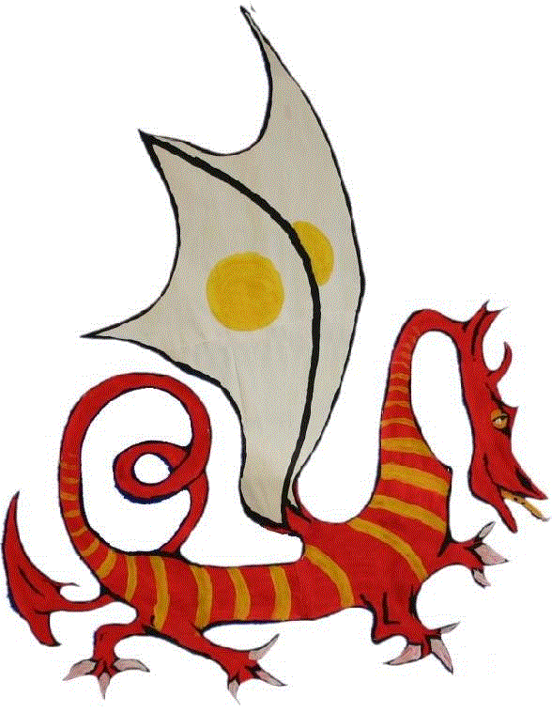

Water in Class Guidance

WATER IN CLASS

As a school we are aware of the need to promote healthy lifestyles and encourage children to make sensible choices to support their good health. We educate children about the benefits of being active and looking after their bodies by eating and drinking well and avoiding harmful substances. We are pleased that these messages are understood and our pupil surveys show that our pupils do know about what they need to do to maintain a healthy life-style.

The NHS guidelines suggest that we should all be taking on 1.2 litres of fluids a day (around 6-8 glasses) although around 20-30% of fluids come from the food that we eat. Avoiding dehydration is important. During hotter times (this summer, for example) and during sporting activities we need to take on more fluids.

If your child has a drink at home before school, 15 minutes of play time to drink, an hour at lunch time to drink and an afternoon drink time, they should be perfectly hydrated in school. When they get home, there are several hours and another meal during which they can take on more fluids.

We encourage children to drink from a named water bottle or drinks fountain. Water is available in the lunch hall and at the water fountain and during the warmer seasons we have pupils acting as water monitors in the playground, who serve fresh water in cups. Drinks bottles should contain only water as this is quenching and has no calories or sugar that may contribute to tooth decay.

We have found that keeping drinking bottles on the table can be a distraction and our teachers do try to minimise disruptions to learning for the benefit or all children. Therefore, we ask that children’s bottles are kept in the class box and if a child feels the need for an extra drink they may do so by asking the adult in class at appropriate times. We would suggest that a maximum of two extra drinking times should be sufficient during the day.

There are some very serious health concerns which do require a constant flow of fluid and we would of course accommodate these circumstances as the wellbeing of all children is paramount. These children will have specialist action plans designated by their consultant. Should your child have such a condition in the future please advise us immediately.

